Name : Laxmi Ramchandra Shejwal

Roll No: 506

Cyber Forensics and Laws

Write a program to take backup of a MySQL database.

# Database:

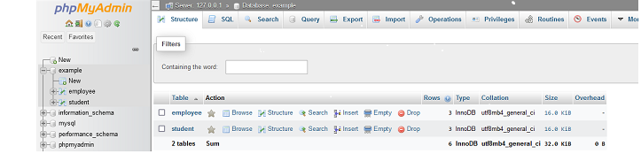

Table :

**Employee :**

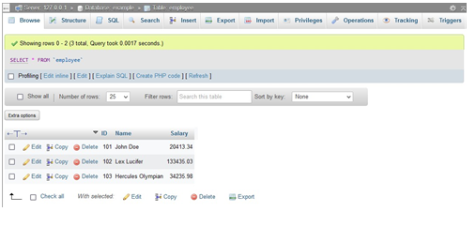

**Student :**

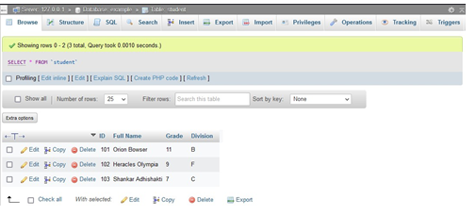

**Code ::**

import mysql.connector as connector

om sys import exit

if _name _ = " _main _":

hostname = input("Enter host name [localhost]>") hostname = hostname if hostname = "" el e "localhost" username = input("Enter your username > ")

if username = "":

exit("Please input the correct username")

print("If password is not set, just press [Enter] on the following prompt")

password = input("Enter your password > ")

database_name = input("Enter the name of the database you want to backup > ")

if database_name = "":

exit("Please input the correct database name")

print("Trying connection...")

try:

connection = connector.connect(host = hostname, user =

username, password = password, database = database_name) cursor = connection.cursor() print("Connection successful")

cursor.execute("show tables;") table_names : list[str] = []

for record in cursor.fetchall(): table_names.append(record[0])

backup_database_name = database_name + "_backup" cursor.execute(f"create database

{backup_database_name};")

cursor.execute(f"use {backup_database_name};")

for table_name in table_names:

cursor.execute(f"create table {table_name} select * from {database_name}.{table_name}")

print("Backup successful")

except:

exit("Connection unsuccessful")

**Output ::** 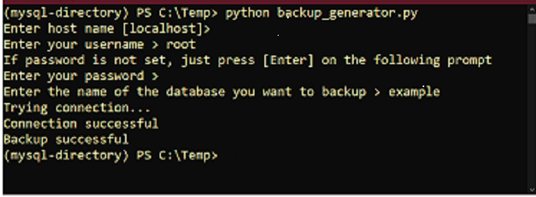

After Backup ::

**Employee Table :**

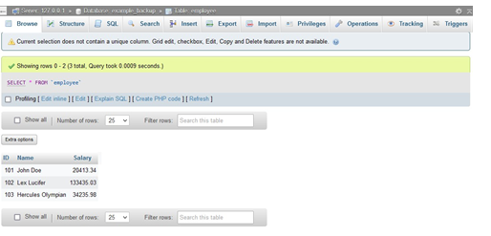

**Student Table**

